Gary Buchenic

[Stop Shin Splints Forever™](http://zzzyouridzzz.shincure.hop.clickbank.net/?tid=zzztidzzz)

All Rights Reserved



**How To Cure Shin Splints**

**IN 3 EASY STEPS**

# **The Pain & Frustration of Shin Splints**

Know what?

I struggled with shin splints for NINE YEARS…

Every treatment technique I tried seemed to give me nothing more than temporary relief… then the next time I'd go for a run the pain would come back, many times I wondered if I'd have to struggle with this condition for the rest of my life.

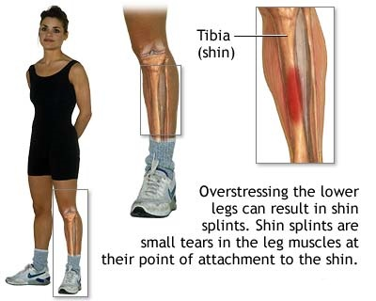And, this drove me NUTS.

My shin pain were so bad at times that I could hardly walk… and I can't tell you how many times I had to miss out on going for one of a morning jog (I love these) or playing soccer on a Tuesday night with my buddies because the pain was too severe…

But I'm here to tell you, that it doesn't have to be like this for you!

Through a TON of trial and error, I've now figured out a method that's literally guaranteed to get rid of shin splints FOREVER. And I want to teach it to you **right now**.

Here's how it works…

# **1. Identify The Causes Of Your Pain**

It's important to understand that shin splints is a "gutter" term that refers to a variety of different conditions and pathologies that lead to pain in the lower half of the (tibia) shinbone.

Over the years I've found that there are four primary underlying causes that are directly responsible for, or contribute to, nearly every single case of shin splints. And you will be able to easily identify them using the simple tests I show you inside my eBook ["Stop Shin Splints Forever™"](http://zzzyouridzzz.shincure.hop.clickbank.net/?tid=zzztidzzz)

Once you've identified which of the underlying causes you have, it's time for step two.

# **2. Treat The Symptoms**

You can't correct the underlying problems if your pain is so severe you can't move. So in this step you'll implement various strategies to help reduce and eliminate your pain so you can focus on correcting the underlying problems that are responsible for it.

Warning: When using this pain-relief technique, keep the ice on for as long as it is comfortable for YOU. There will be slight discomfort from the cold, but as soon as pain, numbness or excessive discomfort is experienced, remove the ice. Otherwise you can end up with ice burn, which is no fun at all!

Here’s one of my favourite techniques: Ice Massage

Regular icing is great technique for relieving pain. It doesn't just numb the pain, it actually causes a rush of blood and nutrients into the area you're icing AND flushes out enzymes that cause pain and inflammation in the injured area.

**Ice massages are even better than regular icing** because they force the cold deep into your muscles and bones which enhances circulation, flushes out the body’s inflammatory response and if you press a little harder, it also breaks up any scar tissue you may have.

Here's How To Do It:

1. Buy some paper cups, fill them with water and put them in your freezer

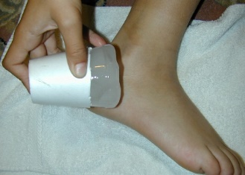2. Pull out a cup and tear off the top half inch or so.

3. Massage the exposed ice into the most painful areas of your shins… you'll KNOW you've found the right spot when you're on it… you'll likely feel a sharp pain there.

4. For a minimum of 5 minutes, push the ice into the painful area and up and down your shins. Keep moving around, don't let the ice sit in one spot too long.

Do this at least 3 times a day. Remember, if your skin gets numb from the cold it's time to stop.

Then you're on to step three, which is…

# **3. Treat The Causes And Condition**

Remember, pain is just a warning signal from your body telling you that you need to fix a problem. So in this step you work on treating the cause, which is the conditions and underlying problems you identified in the first step.

Realize that beginning any treatment without identifying what's really causing your pain is a recipe for failure and frustration.

If you continue using generic, one-size fits all, "conventional" shin splints treatment techniques, you may NEVER address the real causes of your pain and stay stuck with this condition for years. And if you keep exercising or playing the sports that likely CAUSED these underlying problems in the first place, you risk making your condition even worse – or doing PERMANENT damage.

Are you with me?

So use this approach to get rid of shin splints once and for all. Get started today!

I'm here to help you make it happen… in my fully illustrated eBook [Stop Shin Splints Forever™](http://zzzyouridzzz.shincure.hop.clickbank.net/?tid=zzztidzzz), I show you in GREAT detail how to identify what's really causing your pain… In fact, I consider this section where I talk about these things to be the MOST important part of the WHOLE book.

Why?

Because unless you figure out EXACTLY what's causing your shin splints – any treatment techniques you use won't be nearly as effective as they could be.

And when you DO identify the causes, the treatment techniques I teach you for addressing each of these specific causes will be 10x as powerful…

Here’s just a taste of what’s revealed in this breakthrough shin splint treatment program:

* The single most important secret (less than 5% of shin splint sufferers follow) behind **long term shin splint relief**
* A simple, scientifically proven method for getting dramatic relief from your pain **in just 15 minutes**
* Why conventional treatments don’t work and why they often make your shin splints worse
* 5 mistakes to avoid that almost everyone is guilty of, which instead of curing your shin splints, weakens and **destroys your body’s natural ability to heal itself** (and almost everyone is doing it!)
* THE shin splint treatment secret of Jerry Lindgren, one of the greatest runners of all time
* How to **prevent** the reoccurrence of shin splints
* The dirty little secret that the pharmaceutical industry doesn’t want you to know about pain killers

And that’s not nearly all!

Get the full scoop at my webpage here:

[STOP SHIN SPLINTS FOREVER](http://zzzyouridzzz.shincure.hop.clickbank.net/?tid=zzztidzzz)™

Talk soon,  
Gary Buchenic

P.S. Right now, you can get my shin splint treatment program at a special discount! But please note that this price can only be guaranteed for a short period of time.

So, head on over to the [Stop Shin Splints Forever](http://zzzyouridzzz.shincure.hop.clickbank.net/?tid=zzztidzzz) website and see what all the fuss is about. I guarantee you’ll be glad you did!

**[Stop Shin Splints Forever™](http://zzzyouridzzz.shincure.hop.clickbank.net/?tid=zzztidzzz)**

[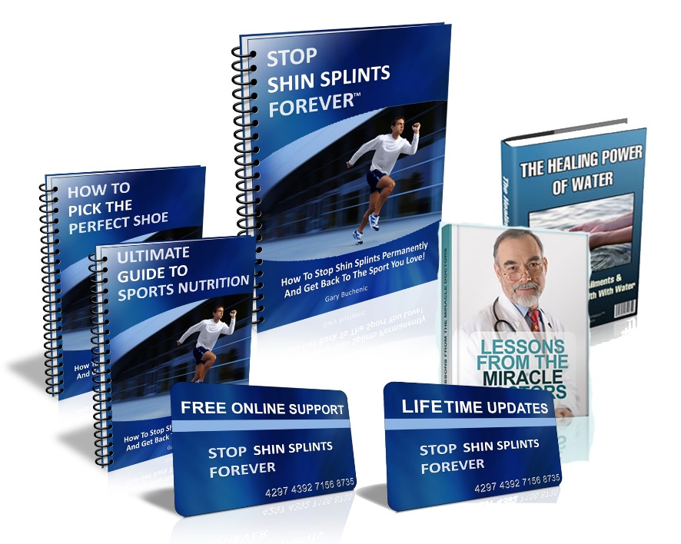](http://zzzyouridzzz.shincure.hop.clickbank.net/?tid=zzztidzzz)

[By Gary Buchenic](http://zzzyouridzzz.shincure.hop.clickbank.net/?tid=zzztidzzz)

[All Rights Reserved](http://zzzyouridzzz.shincure.hop.clickbank.net/?tid=zzztidzzz)